小组成员：冯帆、庞殷、Vincent、潘键、莫英彦

Q1: Generate a summary table like Table 1 Panel A (see slides 9-10)
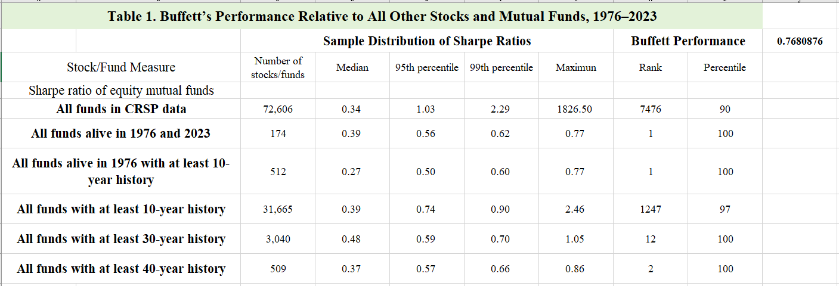
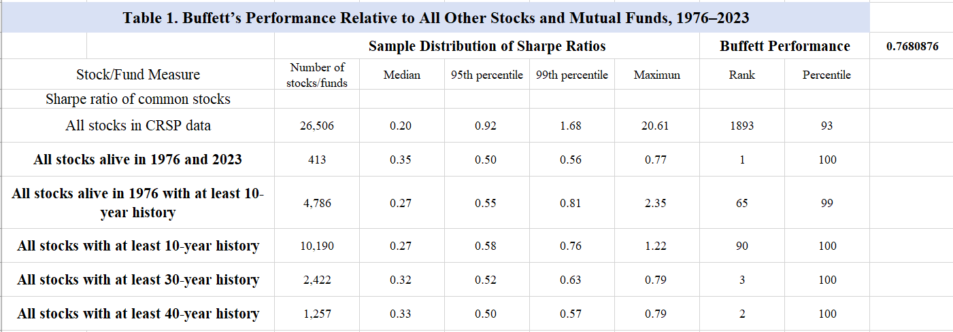
Q2: Plot two graphs like Figure 1 and Figure 2 (see slides 12-13), calculate Sharpe ratio (instead of information ratio)
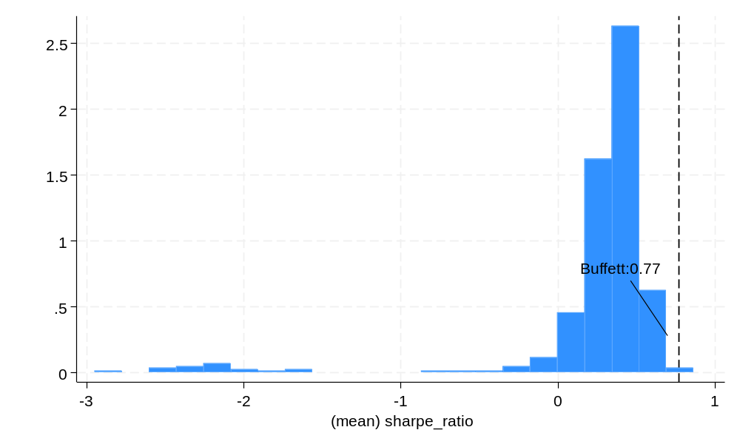
Figure 1 Within fund
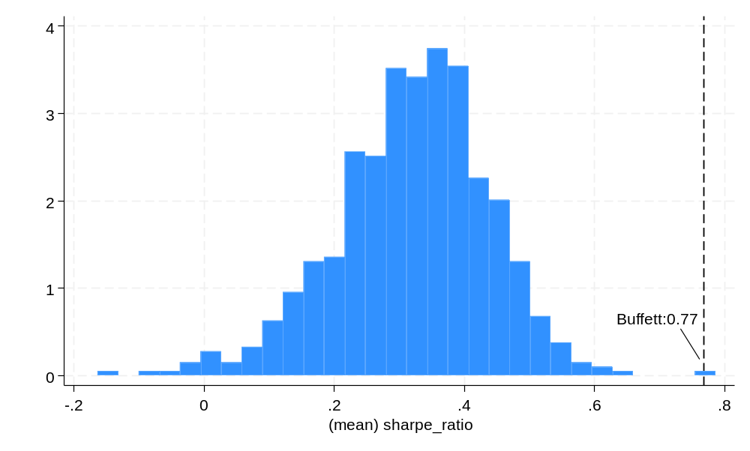
Figure 2 Within stocks
Q3: Generate a summary table like Table 2 (see slide 17), only focus on the performance of Berkshire Hathaway and Public US Stocks (13F portfolio)

This is the Beta, Alpha, Average excess return, Total volatility, Sharpe ratio, idiosyncratic
volatility
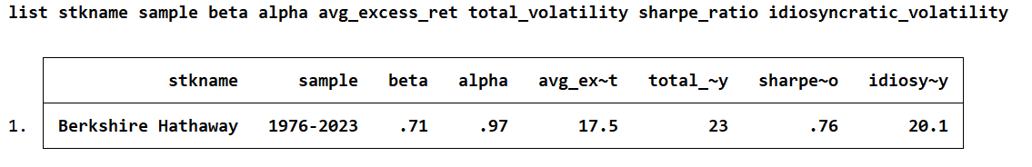
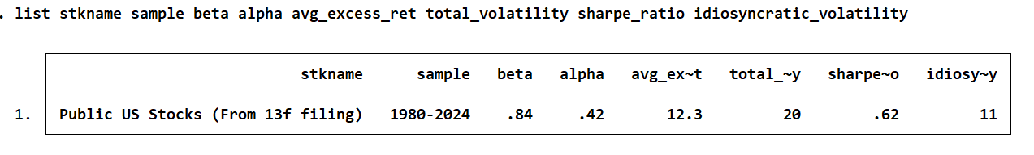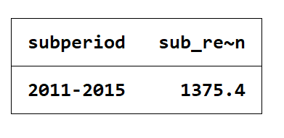
This is the Subperiod excess returns
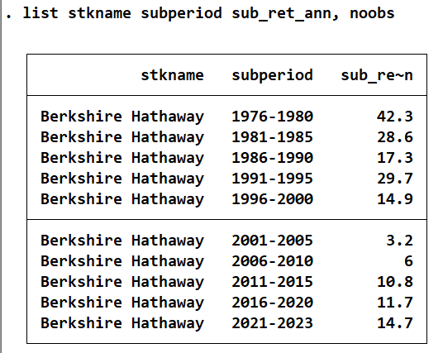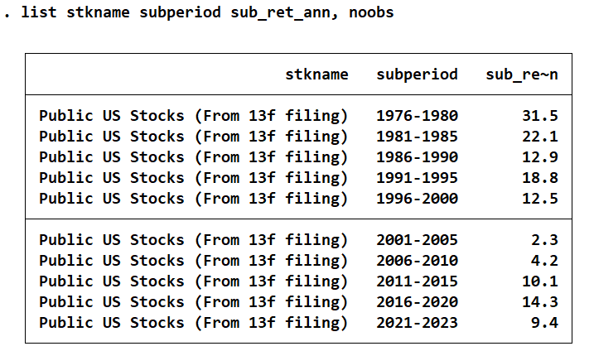

Q4: Generate a regression table like Table 4 (see slide 23), only focus on Berkshire Hathaway and Public US Stocks (13F portfolio)
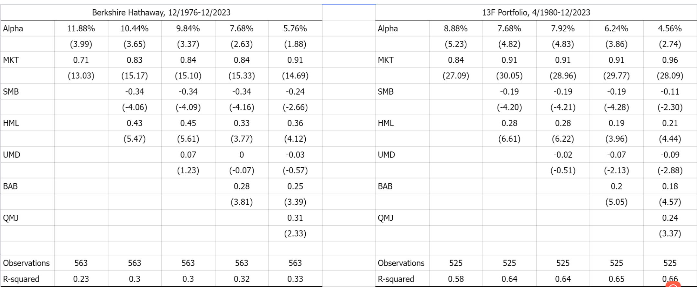

Berkshire Hathaway, 12/1976-12/2023
 | (1) | (2) | (3) | (4) | (5)
VARIABLES | ret_rf | ret_rf | ret_rf | ret_rf | ret_rf
mkt | 0.71*** | 0.83*** | 0.84*** | 0.84*** | 0.91***
 | (13.03) | (15.17) | (15.10) | (15.33) | (14.69)
smb |  | -0.34*** | -0.34*** | -0.34*** | -0.24***
 |  | (-4.06) | (-4.09) | (-4.16) | (-2.66)
hml |  | 0.43*** | 0.45*** | 0.33*** | 0.36***
 |  | (5.47) | (5.61) | (3.77) | (4.12)
umd |  |  | 0.07 | -0.00 | -0.03
 |  |  | (1.23) | (-0.07) | (-0.57)
bab |  |  |  | 0.28*** | 0.25***
 |  |  |  | (3.81) | (3.39)
qmj |  |  |  |  | 0.31**
 |  |  |  |  | (2.33)
Constant | 0.99*** | 0.87*** | 0.82*** | 0.64*** | 0.48*
 | (3.99) | (3.65) | (3.37) | (2.63) | (1.88)
Observations | 563 | 563 | 563 | 563 | 563
R-squared | 0.23 | 0.30 | 0.30 | 0.32 | 0.33
t-statistics in parentheses
*** p<0.01, ** p<0.05, * p<0.1

13F Portfolio, 4/1980-12/2023
 | (1) | (2) | (3) | (4) | (5)
VARIABLES | VW_RET | VW_RET | VW_RET | VW_RET | VW_RET
mkt | 0.84*** | 0.91*** | 0.91*** | 0.91*** | 0.96***
 | (27.09) | (30.05) | (28.96) | (29.77) | (28.09)
smb |  | -0.19*** | -0.19*** | -0.19*** | -0.11**
 |  | (-4.20) | (-4.21) | (-4.28) | (-2.30)
hml |  | 0.28*** | 0.28*** | 0.19*** | 0.21***
 |  | (6.61) | (6.22) | (3.96) | (4.44)
umd |  |  | -0.02 | -0.07** | -0.09***
 |  |  | (-0.51) | (-2.13) | (-2.88)
bab |  |  |  | 0.20*** | 0.18***
 |  |  |  | (5.05) | (4.57)
qmj |  |  |  |  | 0.24***
 |  |  |  |  | (3.37)
Constant | 0.74*** | 0.64*** | 0.66*** | 0.52*** | 0.38***
 | (5.23) | (4.82) | (4.83) | (3.86) | (2.74)
Observations | 525 | 525 | 525 | 525 | 525
R-squared | 0.58 | 0.64 | 0.64 | 0.65 | 0.66
t-statistics in parentheses
*** p<0.01, ** p<0.05, * p<0.1

Q5: After doing the above for Berkshire Hathaway, repeat the same steps on another investment company (using the data https://bb.sustech.edu.cn/bbcswebdav/pid-501866-dt-content-rid-17200689_1/xid-17200689_1 ) that you are interested in (note that you should find a pulicly traded investment company that has stock prices)

We use the stock with PERMNO = 14560, D B X ETF TRUST

On problem3

This is the Beta, Alpha, Average excess return, Total volatility, Sharpe ratio, idiosyncratic
volatility
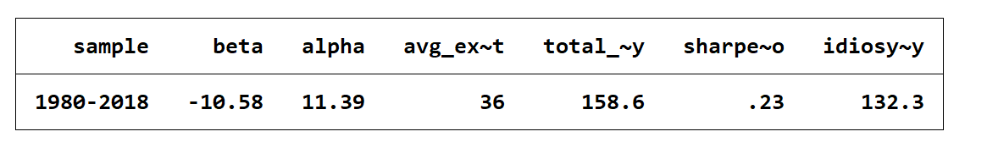

This is the Subperiod excess returns

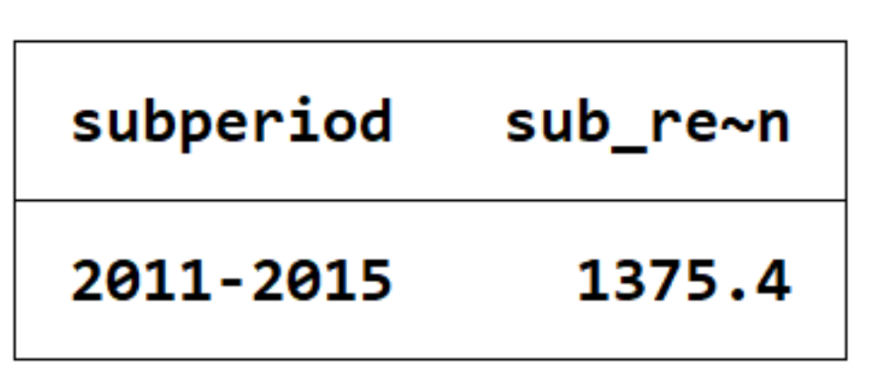

On problem4

